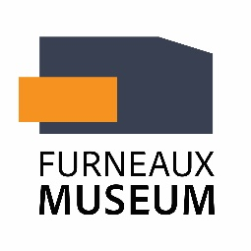

Membership Application 2025-26

 Adult $10.00  Couple $20.00
 Family (2 adults and dependent children) $25.00
 Family (1 adult and dependent children) $15.00
Bank payment details
Account name: Furneaux Historical Research Assoc Inc
BSB: 633-000 Account number: 231 565 334
Reference: SUBS + YOUR NAME

_____________________________________________________________________________________
Please complete and email this form to
reecrawf@gmail.com

Name/s………………………………………………………………………………………….............................................................................
email ………………………………………………………………………………..…………………………………………………………………………..……….
Phone …………………….……...………………………………………………………………..
I/we wish to receive (available via email)  Agendas  Minutes
I/we can help the Museum with the following:
 Museum reception duty – Please state day/s preferred and/or days not available (if any):
…………………………………………………………..……………………………………………………………………….……………………………….….………….
 Working bees/Gardening  Cataloguing/computer work Conservation work
 Exhibitions  Answering research requests
 Something else? ………………………………………………………………………………………………………………………………….…………
________________________________________________________________________________________

